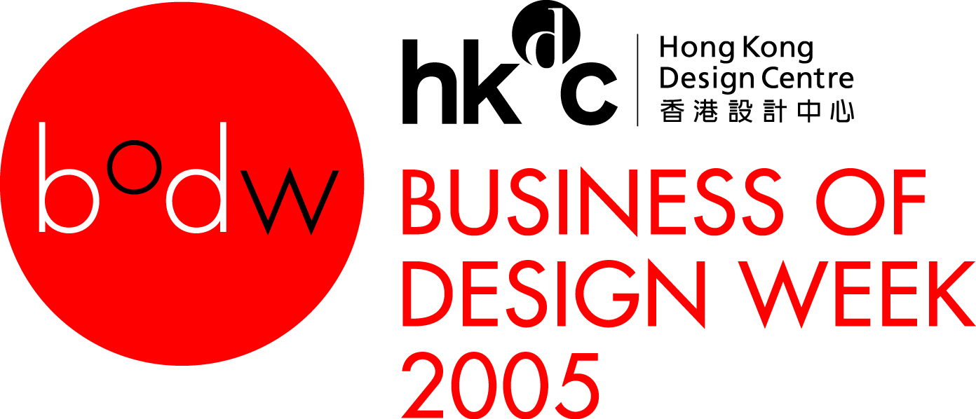
BODW 2005: LifeStyleAsia
International Conference Speakers (as of 3 August 2005)

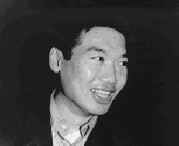 | Arnold Chan  Isometrix Lighting + Design Ltd  Arnold Chan, an architect who was trained at the Architectural Association, has set up Isometrix in 1984. He advocates an innovative and versatile architectural approach to lighting design, which distinguishes the company from the work of more traditional lighting engineers. His approach has redefined the use of colour in lighting. One can clearly see from his work that lighting is not about function anymore, it is about mood and emotion.
 | James Dyson  Dyson  In 2004, James Dyson is awarded Giant Of Design (G.O.D) at Annual House Beautiful Awards, USA. He is the first engineer to give the prestigious Dimbleby Lecture, “Engineering the Difference”, for the BBC in 2004 (UK). Dyson produces his first prototype vacuum cleaner, a very post-modern pink machine called the G-Force, which wins the International Design Fair prize in Japan.
 | Bruce Grenville  Vancouver Art Gallery  Bruce Grenville is the senior Curator at the Vancouver Art Gallery and has been Curator at the Mendel Art Gallery, Saskatoon and Senior Curator of the Edmonton Art Gallery. In addition, he has organized many group exhibitions including The Uncanny: Experiments in Cyborg Culture, a thematic survey of the image of the human machine in art and popular culture from the early 19th century to the present.



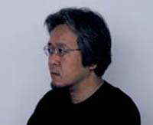 | Kenya Hara  Hara Design Institute  Hara’s design is characterized by its sensuousness, recognizing and delighting in the relationship with the senses like the sense of touch. His work includes the program for the Nagano Winter Olympic Games, the renewal of the Matsuya Ginza department Store. He has been on the board of MUJI since 2001.
 | Yuko Hasegawa  21st Century Museum of Contemporary Art  Yuko Hasegawa is the Artistic Director of 21st Century Museum of Contemporary Art, Kanazawa. She is a board member of the International Committee for Museums and Collections of Modern Art (CIMAM).
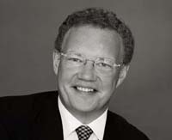 | Hans-Kristian Hoejsgaard  Georg Jensen A/S  Hans-Kristian Hoejsgaard is the President and CEO of Georg Jensen Ltd. He is a brand equity specialist with more than 20 years’ experience in consumer goods, including 16 in luxury goods.

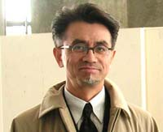 | Pinky Lai  Porsche  Pinky Lai was born in Hong Kong. He was the exterior designer at Ford of Germany, senior exterior designer at BMW Ag, Munich and design manager at BMW Technik. Munich from 1980 to 1989. Since 1989 he was invited to join Porsche R & D, Weissach. One of his missions was the 911Turbo. During its launch at the Detroit Motor Show 2000, the year's planned production had been doubled and was already sold-out. Numerous international design prizes were awarded to the aesthetics of 911 Coup (c), Cabriolet, Targa and Turbo. Since 1999 he is the chief designer of the Boxster exterior.
 | Anthony Lo  Saab Automobile AB  Anthony Lo’s car design career started in 1987 with Lotus Cars in England, and then followed by three years of working experience in Audi’s design studios in Munich and Ingolstadt, Germany. With the opening of the Mercedes-Benz Advanced Design Centre in Japan in 1993, Anthony Lo had taken up the position of Chief Designer and moved to Tokyo. In October 2000, he moved to Sweden to head the Advanced Design studio for Saab Automobile AB and became the Advanced Design Director of General Motors Europe in 2004.
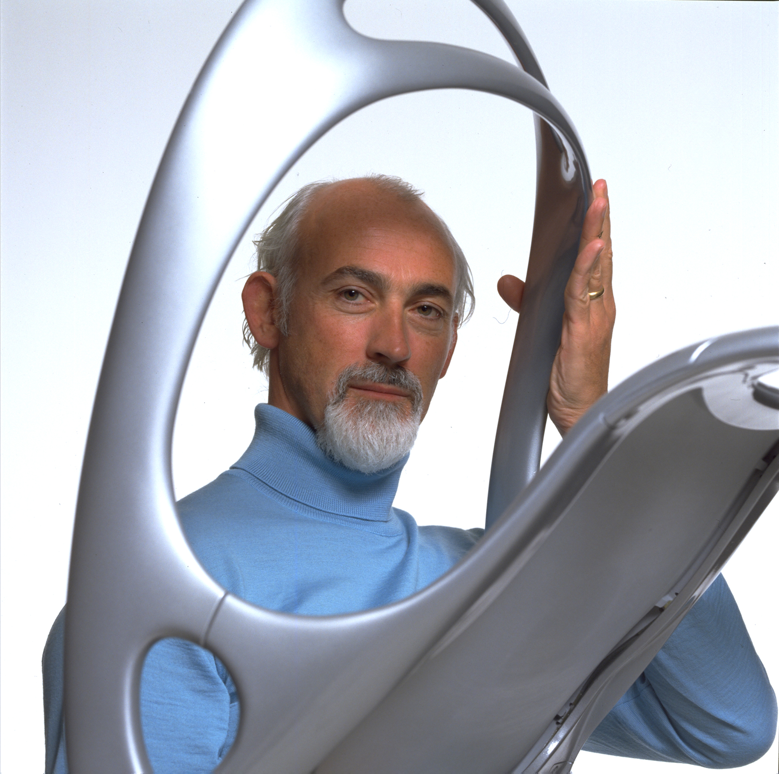 | Ross Lovegrove  Lovegrove  Lovegrove is the winner of numerous international awards. Many of Lovegrove’s designs address ecological issues. Lovegrove’s humanistic approach and organic sensibility have set a direction for design in the next century.

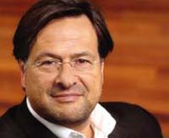 | Stefano Marzano  Philips Design  Stefano Marzano is an architect and designer. Since 1991, Marzano is CEO & Chief Creative Director of Philips Design, the in-house international design group of Philips Electronics, responsible for the design of all the Divisions and companies of the Philips Group.
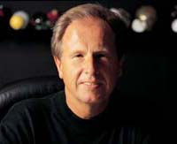 | Chuck Pelly  Pelly Design Management  Chuck Pelly, is a 40-year veteran of the design industry. He has done works from sketching futuristic go-karts for Hot Rod magazine to designing race cars, snowmobiles, farm equipment, campers, catamarans and vehicles for GM, Chrysler, American Motors, Mazda, Subaru and BMW. Chuck Pelly has been awarded more than 40 US and foreign patents and received over 50 awards of distinction. He has been President of the Industrial Design Society of America, and an IDSA Fellow since 1994.
 | Ye Weiyang  Lotosland design workshop  Lotosland advocates an East meets West design. The Design Academy is currently working with Lotosland in Shenzhen, China on designing Lifestyle Furniture and Accessory Packages to be initially sold in China and Australia. Seven lines of furniture will be introduced which are complete coordination of living, dining, bedroom and entertainment rooms throughout the home under a new brand, Lotos Come Home.
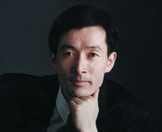 | Zhang Wu  Armstrong International Corporate Identity Co., Ltd.  Zhang Wu, president of Beijing Armstrong International Corporate Identity established in 1992, is a renowned Graphic Designer and Brand Management Expert and has led the company's design team to create the logo for the Beijing 2008 Olympics, entitled "Chinese Seal -- Dancing Beijing". The logo was chosen from among almost 2000 designs submitted to the Beijing Organizing Committee.

